**Weather Forecast App**

### A PROJECT REPORT

***Submitted by***

**MOHIT KARIA**

**92100103401**

# KRUTI VADALIYA

**92100103349**

**TEJ DEKIWADIYA**

**92100103011**

# BACHELOR OF TECHNOLOGY

***in***

**Computer Engineering**



## Marwadi University, Rajkot

#### October, 2024



**Major Project-I (01CE0716)**

**Marwadi University Faculty of Technology**

Department of Computer Engineering

## 2024-25

**CERTIFICATE**

This is to certify that the project report submitted along with the project entitled **WEATHER FORECAST APP** has been carried out by **Mohit Karia** (92100103401), **Kruti Vadaliya** (92100103349) & **Tej Dekiwadiya** (92100103011) under my guidance in partial fulfilment for the degree of Bachelor of Technology in Computer Engineering, 7th Semester of Marwadi University, Rajkot during the academic year 2024-25.

_______________ ________________

Prof. Harsh Nagar Dr. Krunal Vaghela

Assistant Professor Head of the Department

Internal Guide



**Marwadi University**

### Rajkot

**DECLARATION**

We hereby declare that the **Major Project (01CE0716)** report submitted along with the Project **Weather Forecast App** entitled submitted in partial fulfilment for the degree of Bachelor of Technology in Computer Engineering to Marwadi University, Rajkot, is a bonafide record of original project work carried out by me / us at Marwadi University under the supervision of **Prof. Harsh Nagar** and that no part of this report has been directly copied from any students’ reports or taken from any other source, without providing due reference.

Name of the Student Sign of Student



## Acknowledgement

Before proceeding to the contents of this module, we would like to express our gratitude to our Internal Guide, **Prof. Harsh Nagar** and our Head of the Department, **Dr. Krunal Vaghela** who are our continual source of inspiration. They pushed us to think imaginatively and urged us to do this project without hesitation. Their vast knowledge, extensive experience, and professional competence in web domain enabled us to successfully accomplish this project. This endeavour would not have been possible without their guidance. This initiative would not have been a success without the contributions of each and every individual. We were always there to cheer each other on, and that is what kept us together until the end.

We would like to thank The Marwadi University for providing us with the opportunity to work on the project **WEATHER FORECAST APP**. Also, we are deeply grateful to everyone who has contributed to the successful completion of this project.

## Abstract

The Weather Forecast System is an innovative web application developed using the MERN stack, designed to deliver personalized weather updates and enhance user convenience. The system features real-time weather data, a 5-day forecast, and interactive geographical mapping for the user’s registered city. Secure user authentication ensures personalized services, while the city search functionality allows users to explore weather conditions globally. By integrating APIs like OpenWeatherMap and Google Maps, the application provides accurate, reliable, and up-to-date weather information.

A distinctive feature of the system is its use of generative AI to predict future weather conditions for user-selected dates, offering actionable recommendations and safety precautions. The intuitive and responsive dashboard ensures a seamless user experience across devices, while the system’s scalable architecture supports future growth. This project combines technical efficiency with user-focused design, addressing both functional and operational needs to deliver a comprehensive weather forecasting solution*.*

### Table of Contents

Acknowledgement i

Abstract ii

Table of Contents iii

List of Figures… v

Chapter 1.0 Introduction to Project and Project Management

* 1. Project Summary 1
  2. Purpose 1
  3. Objective 2
  4. Scope (what it can do and can’t do) 2
  5. Technology 2
  6. Project Planning 3
     1. Project Development Approach and Justification 3
     2. Project effort and time, Cost Estimation 4
  7. Project Scheduling (Gantt Chart) 5

Chapter 2.0 System Analysis

* 1. Study of Current System 6
  2. Problem and Weakness of Current System 7
  3. Requirement of New System 7
  4. System Feasibility 8
     1. Does the system contribute to the overall objectives of the organization? 8
     2. Can the system be implemented using the current technology and within

the given cost and schedule constraints… 8

* + 1. Can the system be integrated with other systems which are already in Place? ……………………………………………………………………………………8
  1. Proposed System …………………………………………………………………………8
  2. Features of New System / Proposed System………………………………………………9
  3. Selection of Hardware / Software …………………………………………………………10

Chapter 3.0 System Analysis

* 1. System Design & Methodology 11

Flow Chart 12

* 1. Database Design 13
  2. Input and Output and Interface Design (If applicable) 13
     1. ER Diagram 13
     2. Data Flow Diagram 14

Chapter 4.0 Implementation

* 1. Modules Specification(s) 15
  2. Implementation of Platform 16

Chapter 5.0 Testing

* 1. Testing Plan 19
     1. Authentication 19
     2. Location tracking and Mapping 19
     3. Service request management………………………………………………………..20
     4. User Review………………………………………………………………………...20
  2. Test Results and Analysis 21
     1. Test Cases (test ID, test condition, expected output, actual output, remark) 21
     2. Result Analysis / Comparison 21

Chapter 6.0 Conclusion & Outcomes

* 1. Overall Analysis of Project Viabilities 22
  2. Problem Encountered and Possible Solutions 22
  3. Summary of Project work… 23
  4. Limitations and Future Enhancement… 23
  5. Project Outcomes… 24

References 25

### List of Figures

Fig 1.7 Gantt Chart 5

Fig 3.1 Flow Chart 12

Fig 3.2 Database Design 13

Fig 3.3.1 ER Diagram .13

Fig 3.3.2 Data Flow Diagram 14

Fig 4.2.1 Login Page 16

Fig 4.2.2 Register Page 16

Fig 4.2.3 Dashboard Page 17

Fig 4.2.4 Search Page 17

Fig 4.2.5 Weather Report 18

# CHAPTER 1

**INTRODUCTION TO PROJECT AND PROJECT MANAGEMENT**

### Project Summary

* The Weather Forecast App is a dynamic web application built using the MERN stack (MongoDB, Express.js, React.js, and Node.js).
* It allows users to check real-time weather conditions for various locations worldwide. The app fetches weather data from an external API and displays detailed forecasts, including temperature, humidity, and wind speed.
* Users can search for specific cities, view current weather conditions, and get updates on upcoming weather trends.
* The responsive design ensures a seamless user experience across devices. MongoDB stores user preferences and search history, while Express.js and Node.js handle server-side operations. React.js powers the interactive front-end, providing a smooth and intuitive interface.

### Purpose

* A weather forecast app is designed to provide users with up-to-date information about the weather conditions in their area or any location they choose. The main purposes of a weather forecast app include:
* Real-Time Weather Updates: Offering current weather conditions, such as temperature, humidity, wind speed, and precipitation, so users can plan their activities accordingly.
* Forecast Predictions: Providing short-term (hourly) and long-term (daily or weekly) weather forecasts to help users prepare for upcoming weather changes.
* Alerts and Notifications: Sending notifications about severe weather conditions, such as storms, heatwaves, or heavy rainfall, to keep users informed and safe.
* Travel and Outdoor Planning: Assisting users in planning trips, outdoor activities, or daily commutes by providing information about weather conditions that may affect their plans.
* Customizable Locations: Allowing users to check the weather in multiple locations, which is useful for travelers, or those with family or friends in different regions.
* Weather Insights: Offering additional data such as air quality, UV index, or pollen count, which can be crucial for health-conscious users or those with specific needs.

### Objective

* Provide accurate, real-time weather updates.
* Offer short-term and long-term weather forecasts.
* Alert users to severe weather conditions for safety.
* Assist in planning daily activities and travel.
* Enhance user experience with a simple, intuitive interface.
* Allow customization of locations and alerts for personalized use.

### Scope (what it can do and can’t do)

* **What It Can Do**
* Show current weather conditions like temperature and rain.
* Give weather predictions for the next hours, days, or week.
* Send alerts about bad weather, like storms or heatwaves.
* Let you check the weather in different places around the world.
* Provide extra info like air quality or UV levels.
* **What It Can’t Do:**
* Always be 100% accurate, as weather can be unpredictable.
* Change or control the weather.
* Guarantee precise forecasts for longer than a week.
* Make decisions for you—it's up to you to use the information wisely.

### Technology

#### Frontend Development:

* React.js: Builds dynamic, interactive weather apps.
* Tailwind CSS: Helps create clean, responsive designs quickly.

#### APIs:

* OpenWeatherMap: Provides real-time weather data.
* React Leaflet: Displays weather data on interactive maps.

#### Backend Development:

* Node.js + Express.js: Manages server-side logic and handles data efficiently.

#### Authentication:

* JWT: Secures user login with tokens.
* bcrypt: Encrypts passwords for safe storage.
* **Database:**
* MongoDB: Stores and manages large amounts of data flexibly.

### Project planning

### Project Development Approach and Justification

#### Key Components:

* + - * Iterative Progression: Development occurs in small increments (sprints) for regular assessment and adaptation based on user feedback.
      * User-Centric Design: Continuous interaction with stakeholders ensures the project meets user expectations.
      * Flexibility: Agile accommodates changes in requirements at any stage, allowing for new ideas and enhancements.

#### Justification:

* + - * Rapid Development: Enables quick delivery of functional components for early testing and user feedback.
      * Improved Quality: Frequent testing helps identify and address issues early in the development process.
      * Enhanced Collaboration: Regular communication fosters alignment among developers, designers, and stakeholders.
      * User Engagement: Continuous feedback leads to a more user-friendly application.
      * Risk Management: Early identification and mitigation of risks minimize future issues.

### Project effort and Time, Cost Estimation

#### Project Effort Estimation:

Total Estimated Time: 16 weeks (4 months) Requirement Gathering: 2 weeks

Design: 2 weeks

Frontend Development: 3 weeks Backend Development: 3 weeks Database Design: 2 weeks Testing: 2 weeks

Deployment: 1 week

Documentation and Training: 1 week

#### Time Estimation:

Total Estimated Time: 16 weeks (4 months) Requirement Gathering: 2 weeks

Design: 2 weeks

Frontend Development: 3 weeks Backend Development: 3 weeks Database Design: 2 weeks Testing: 2 weeks

Deployment: 1 week

Documentation and Training: 1 week

#### Cost Estimation:

Total Hours: 670 hours

Average Hourly Rate: $25/hour, Total=$16,750

### Project Scheduling (Gantt Chart)

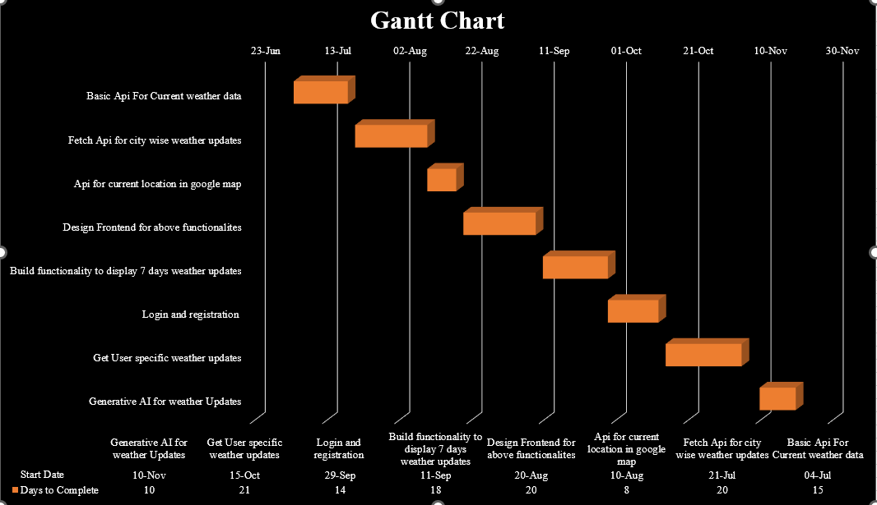

Fig 1.7 Gantt Chaart

# CHAPTER 2 SYSTEM ANALYSIS

### Study of Current System

* **Weather Data Collection:**

Weather data is gathered from sources like satellites and weather stations, including temperature, rain, wind, and more.

* **Data Processing:**

This data is analyzed using special models to predict future weather.

* **API Services:**

Services like OpenWeatherMap provide this processed weather data through APIs, which apps use to get weather information.

* **User Interaction:**

The app uses this data to show users current weather, forecasts, and maps, often based on their location.

* **Limitations:**

Accuracy: Forecasts can be inaccurate, especially long-term.

Customization: Some apps may not offer advanced features for personalized alerts.

Data Overload: Too much information can be overwhelming if not presented simply.

### Problem and Weakness of Current System

1. Accuracy Issues:

- Inaccurate forecasts, especially for long-term predictions or rapidly changing conditions.

2. Limited Customization:

- Lack of personalized alerts and customizable display options.

3. Data Overload:

- Excessive information without clear organization, leading to user confusion.

4. Real-Time Updates:

- Delays in updating weather data, resulting in outdated information.

5. User Interface:

- Non-intuitive design that hampers navigation and data interpretation.

6. Integration Issues:

- Limited integration with other apps and systems, reducing overall functionality.

### Requirement of New System

The new Weather Forecast System aims to deliver a personalized and interactive weather experience. It allows users to register with their email, password, and city, ensuring tailored weather information based on their preferences. Upon login, the system provides real-time weather updates and a 5-day forecast for the registered city, enabling users to plan ahead effectively. The dashboard includes an interactive map displaying the user’s current geographical location and features a seamless navigation button to search for weather details in other cities. This ensures a comprehensive experience that combines local and global weather insights.

A standout feature is the integration of generative AI, which empowers users to input future dates and receive detailed weather predictions. This includes practical recommendations and precautions to enhance safety and preparedness. The system is built on a scalable MERN stack architecture, ensuring fast data retrieval, robust performance, and secure user data management. Designed to handle high traffic and deliver a responsive interface, it provides a reliable, feature-rich solution for personalized weather forecasting.

### System Feasibility

* + 1. **Does the System Contribute to Overall objectives of the organization?**

Enhances User Engagement: Provides timely weather info.

Increases Accessibility: Easy access to weather data.

Supports Decision-Making: Helps users make informed choices.

### Can the System be implemented using the current technologyand within the given cost and schedule constraints

Technology: Current tech stack (React.js, Node.js) is suitable and widely used.

Cost: Affordable with free or low-cost tools and APIs.

Schedule: Feasible within standard development timelines.

### Can the system be integrated with other systems which are already in place?

Yes, the Weather Forecast System is designed to integrate seamlessly with existing systems to enhance functionality and interoperability. It can connect with third-party weather APIs like OpenWeatherMap or others, allowing flexibility in data sourcing for real-time and forecasted weather information. Geolocation services, such as Google Maps or Mapbox, enable compatibility with existing mapping and navigation platforms. The generative AI module can integrate with pre-existing AI systems or APIs for advanced weather analysis. Additionally, it can be linked to enterprise solutions, mobile apps, or dashboards to provide supplementary weather alerts and insights, ensuring smooth collaboration with other systems in place.

### Proposed System

### The proposed Weather Forecast System offers a personalized and interactive weather experience. Users can register with their email, password, and city to receive real-time updates and a 5-day forecast tailored to their location. The dashboard features an interactive map showing the user's current geographical location and allows searching for weather details of other cities. Generative AI integration enables users to predict future weather conditions with recommendations and precautions. Built on the MERN stack, the system ensures secure data management, fast performance, and scalability, making it an efficient, user-centric, and future-ready weather solution.

### Features of New system/ Proposed system

• **User Authentication:**

Secure registration and login using email and password, with personalized weather data based

on the user’s registered city.

• **Real-Time Weather Updates:**

Display current weather conditions for the registered city, ensuring up-to-date information.

• **5-Day Weather Forecast:**

Provide a 5-day weather forecast for the registered city to help users plan ahead.

• **Geographical Mapping:**

Interactive map to show the user’s current location and display corresponding weather data.

• **City Search Functionality:**

Allows users to search for weather details of other cities, enhancing the system’s flexibility.

• **Generative AI Integration:**

Predicts future weather conditions for user-selected dates and offers personalized recommendations and precautions.

• **Responsive Dashboard:**

A user-friendly interface that displays weather updates, 5-day forecasts, and maps in a centralized view.

### Selection of Hardware/ Software

#### Hardware Requirements:

* + **Processor:** A modern multi-core processor (e.g., Intel Core i5 or higher) is essential for smooth operation of the website, handling multiple requests and ensuring fast processing for tasks like GPS tracking, real-time communication, and location-based service coordination.
  + **Memory (RAM):** A minimum of **4GB RAM** is recommended for end-user devices to ensure smooth browsing and interaction with the website. The server should have **16GB or more** of RAM to handle high traffic, multiple user requests, and data processing efficiently.
  + **Storage:** Users will need **at least 2GB of free storage** for smooth operation, especially for accessing location data and service-related information.

#### Software Requirements:

* + **Operating System Compatibility:** T The website should be compatible with major web browsers, such as **Google Chrome**, **Mozilla Firefox**, **Safari**, and **Microsoft Edge**, on various devices including desktops, laptops, tablets, and smartphones. It should also be fully responsive, adapting to different screen sizes and devices.
  + **Development Environment:** The website will be developed using **HTML5, CSS3**, and **JavaScript** for the frontend. The backend will use a **MySQL** database to store user data, service provider information, and interaction logs.
  + **Screen Size and Resolution:** The website should be responsive and adapt to different screen sizes and resolutions. It should provide a consistent and user- friendly experience across devices, from desktops with large screens to smaller mobile devices with limited screen real estate. The layout should be optimized for both mobile and desktop users to ensure accessibility and usability.

# CHAPTER 3 SYSTEM DESIGN

### System Design

**Frontend:**

* React.js: Manages the user interface, displaying weather data dynamically and interactively.
* Tailwind CSS: Styles the UI for a clean, responsive design.

**Backend:**

* Node.js + Express.js: Handles server-side logic, processes API requests, and manages data flow between the frontend and the database.

**Database:**

* MongoDB: Stores user data, preferences, and historical weather data.

**APIs:**

* OpenWeatherMap: Provides current weather data and forecasts.
* React Leaflet Map Component: Integrates interactive maps to visualize weather information.

**Components:**

* User Interface: Displays current weather, forecasts, and interactive maps. Users can customize their view and set alerts.
* Authentication: Uses JWT for secure user login and bcrypt for password encryption.
* Data Processing: Fetches weather data from APIs, processes it, and updates the UI in real-time.
* **Methodology**

**1. Requirement Analysis:**

   - Identify core features.

**2. Design Phase:**

   - Create UI/UX designs and prototypes.

   - Define app architecture and data flow.

**3. Implementation:**

   - Build frontend with React.js and Tailwind CSS.

   - Set up backend with Node.js and Express.js.

   - Integrate APIs (OpenWeatherMap, React Leaflet).

**4. Testing:**

   - Perform unit, integration, and user testing.

**5. Deployment:**

   - Host on AWS, Heroku, or Vercel.

**6. Maintenance:**

   - Regular updates and ongoing support.

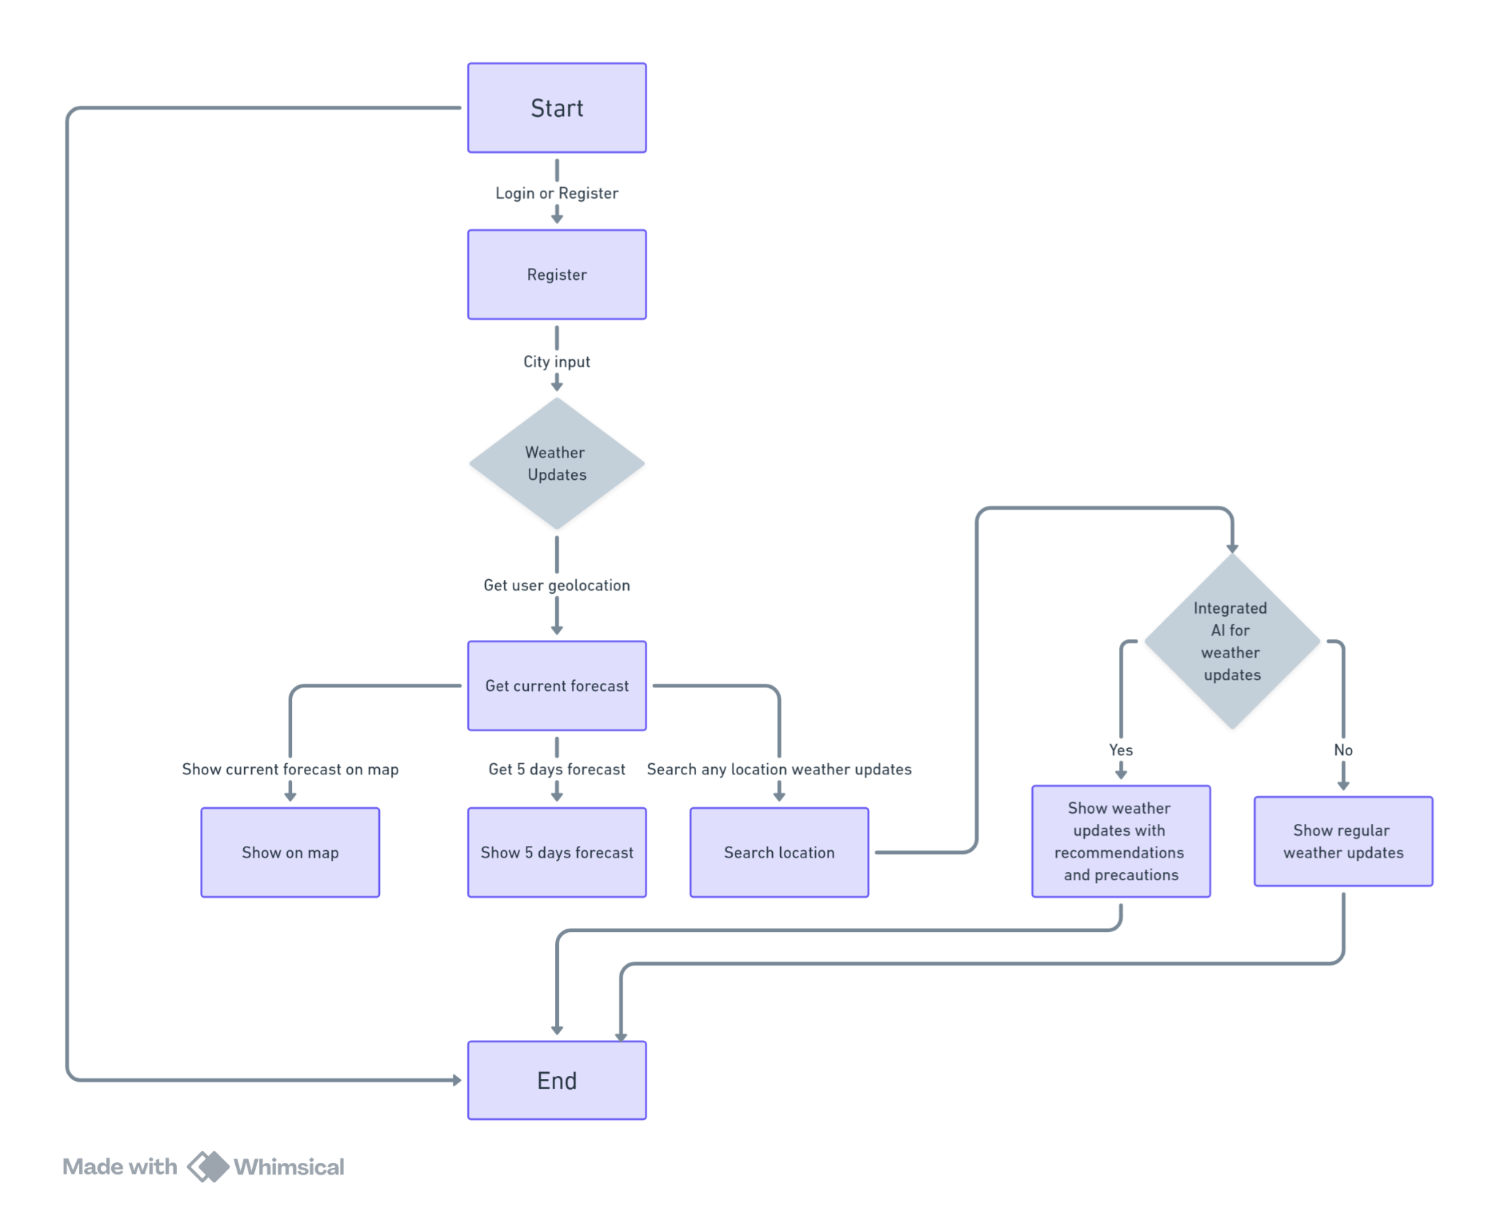

Fig 3.1 Flowchart of Weather Forecast App

### Database Design:

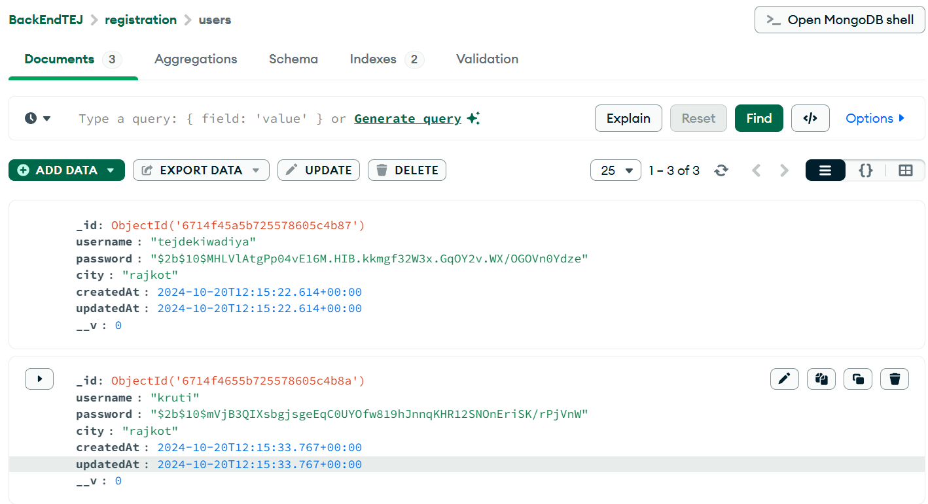

Fig 3.2 Database Design

### Input and Output and interface Design :

### ER DIAGRAM

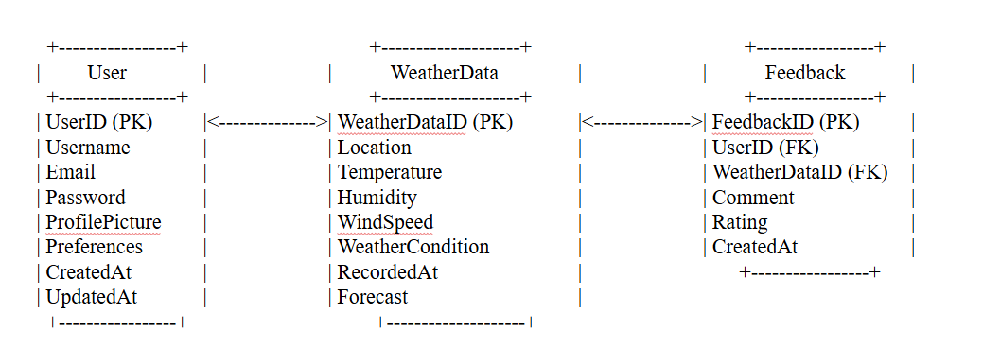

Fig 3.3.1 ER Diagram

### Data Flow DIAGRAM

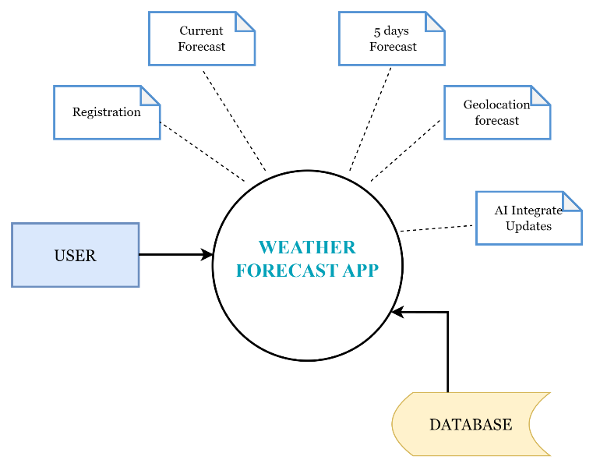

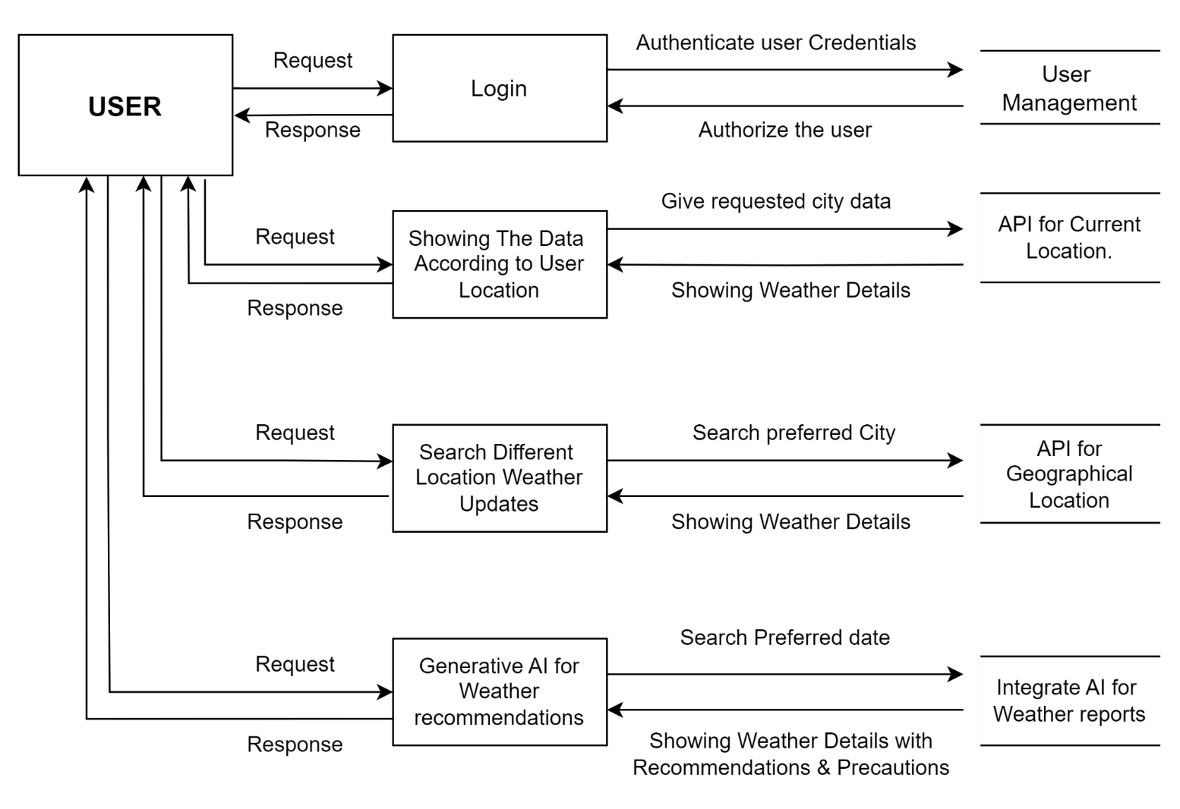

Fig 3.3.2 Data Flow Diagram

# CHAPTER 4 IMPLEMENTATION

### Modules Specification(s)

**1. User Authentication and Management Module:**

* **Purpose:** Handles user registration, login, and profile management securely.
* **Features:**
  + Registration with email, password, and city.
  + Login/logout functionality with session management using JWT.
  + Edit profile details such as updating the city.

**2. Weather Data Display Module:**

* **Purpose:** Fetches and displays weather information specific to the user’s needs.
* **Features:**
  + Real-time weather updates for the registered city.
  + 5-day weather forecast for planning.
  + Displays weather data from external APIs (e.g., OpenWeatherMap).

**3. Geolocation and Map Module:**

* **Purpose:** Displays the user’s current geographical location on a map.
* **Features:**
  + Integration with Mapbox or Google Maps API.
  + Visual representation of the user’s location and weather data.

**4. City Search Module:**

* **Purpose:** Allows users to search for and view weather details of other cities.
* **Features:**
  + Search functionality for any city worldwide.
  + Fetches and displays real-time and forecasted weather for the searched city.

**5. Generative AI Weather Prediction Module:**

* **Purpose:** Predicts weather conditions for future dates using generative AI.
* **Features:**
  + Users can input future dates to get weather predictions.
  + Provides actionable recommendations and safety precautions based on predictions.

**6. Dashboard Module:**

* **Purpose:** Acts as the central interface for users to access weather updates and system features.
* **Features:**
  + Displays personalized weather data for the registered city.
  + Includes navigation options for city search and map view.

**7. API Integration Module:**

* **Purpose:** Connects to third-party services to fetch data and enhance functionality.
* **Features:**
  + Fetches weather data from OpenWeatherMap API.
  + Integrates with Mapbox or Google Maps for location services.

### Implementation of Platform

#### Login page:

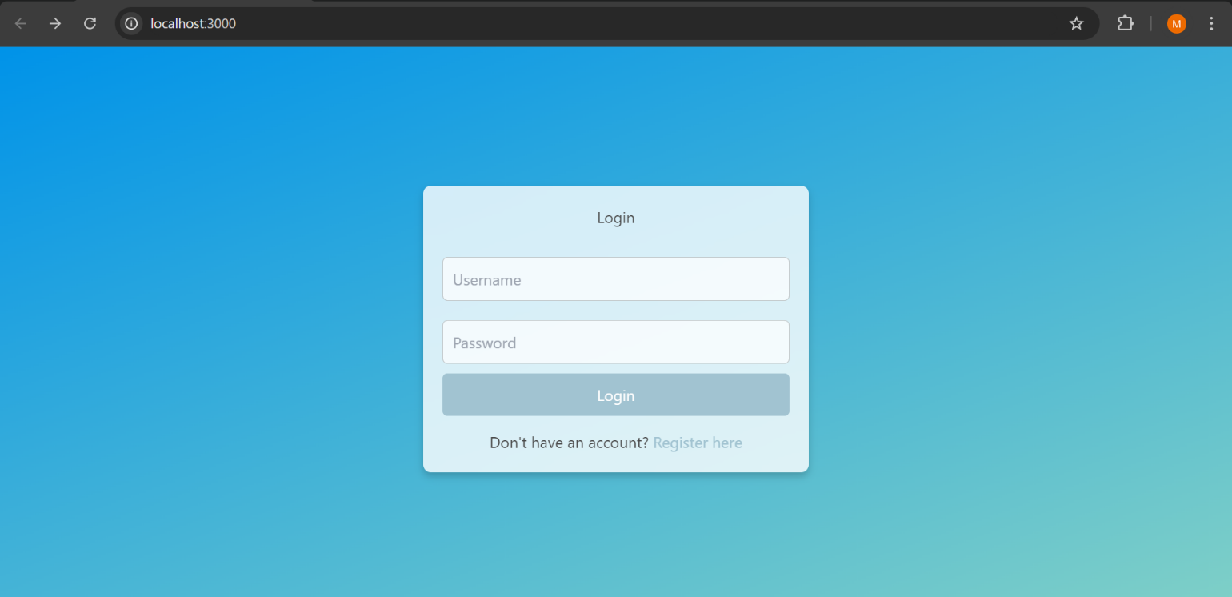

Fig 4.2.1 Login Page

#### Register Page:

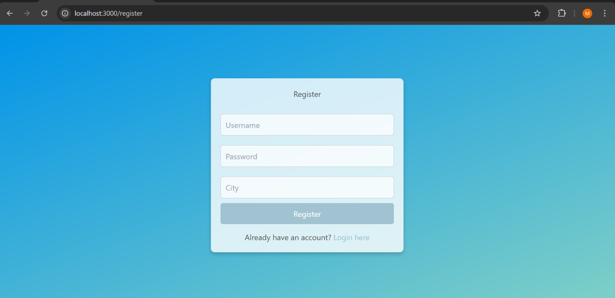

Fig 4.2.2 Register Page

#### Dashboard Page:

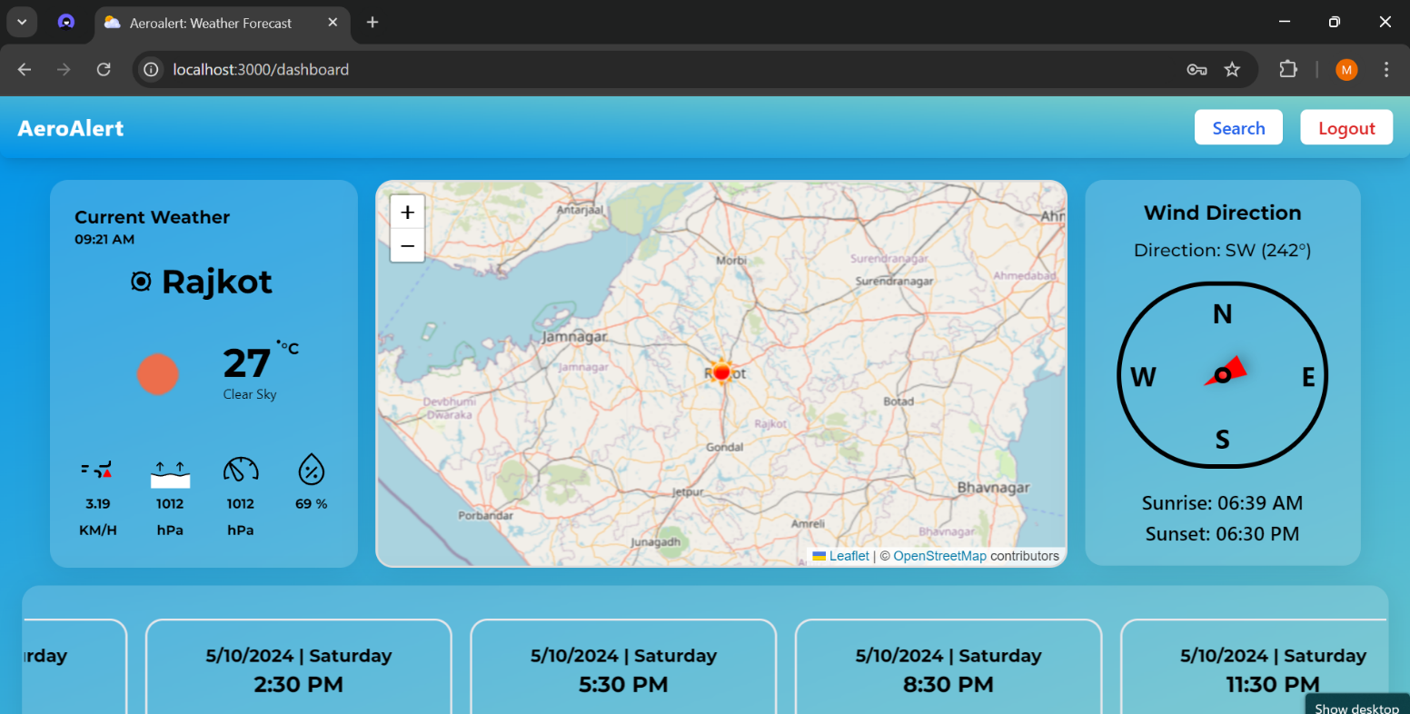

Fig 4.2.3 Dashboard Page

#### Dynamic Search Page :

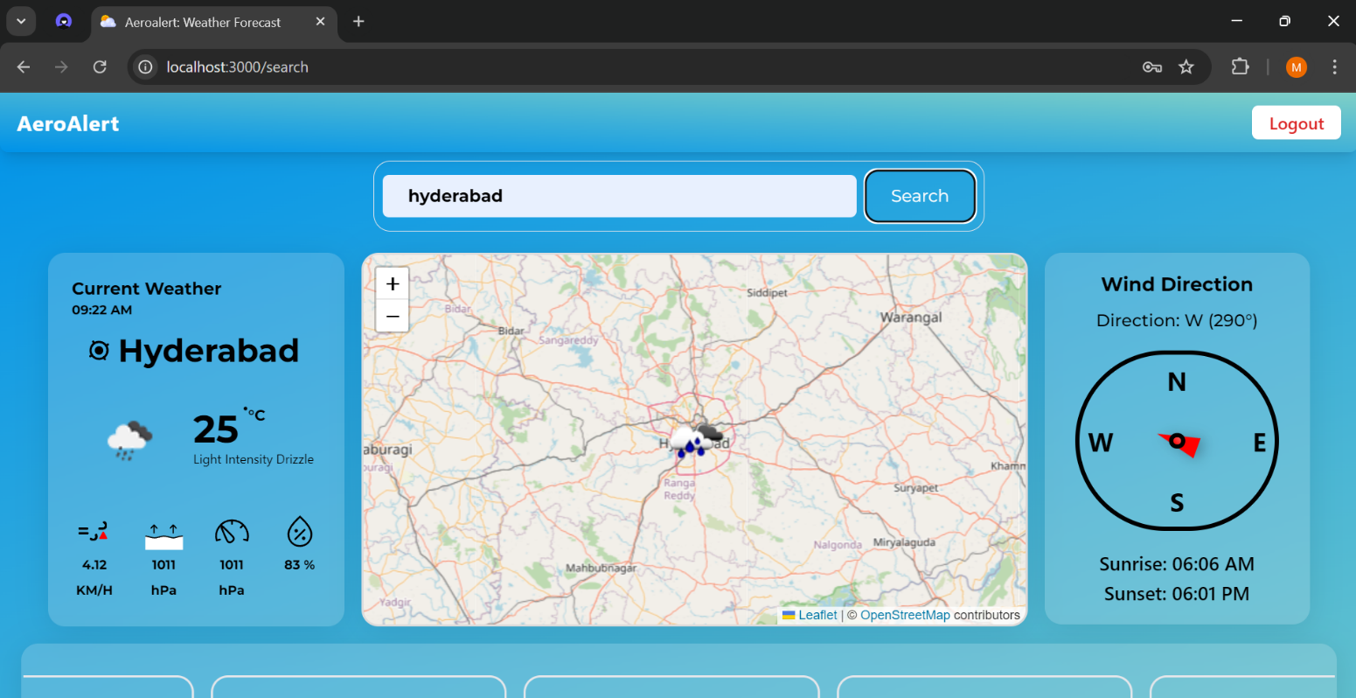

Fig 4.2.4 Search Page

#### World Any City Data:

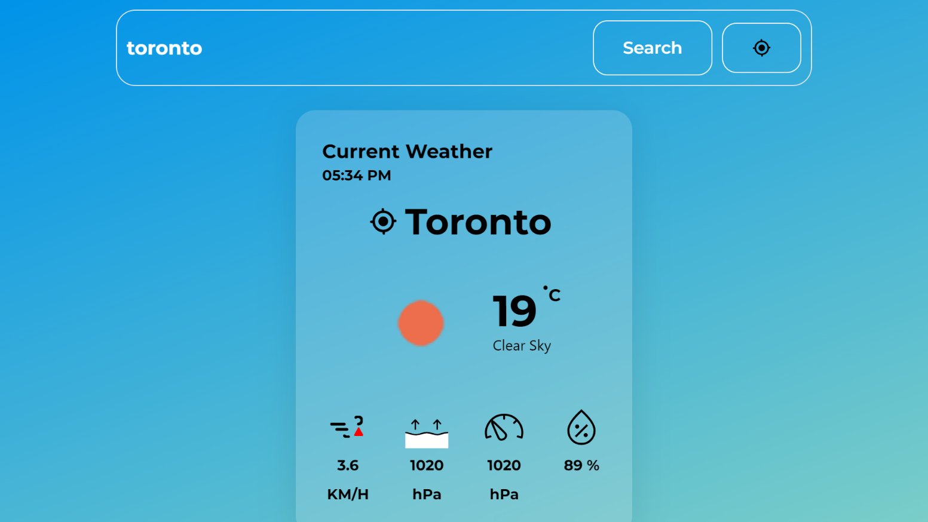

Fig 4.2.5 Weather Report

# CHAPTER 5 TESTING

### Testing Plan

The testing plan for the Weather Forecast System includes thorough validation to ensure functionality, performance, and security. **Unit testing** will verify individual components like user authentication, weather data retrieval, and AI predictions. **Integration testing** will ensure smooth interaction between modules, such as linking the dashboard with APIs and maps. **Performance testing** will evaluate system response times under varying loads, ensuring scalability. **Usability testing** will focus on user experience, ensuring the interface is intuitive and responsive across devices. Finally, **security testing** will validate data protection measures, including secure authentication and API key management, ensuring a reliable and robust system.

**5.1.1 Authentication:**

* Login Page:
  + - * **Valid Credentials:** Verify users can successfully log in with correct credentials.
      * **Invalid Credentials:** Ensure appropriate error messages are displayedfor incorrect login attempts.

#### Database:

**Data Integrity:** Ensure data accuracy, consistency, and adherence to constraints.

**Data Retrieval:** Verify accurate and efficient data retrieval through queries. Verify that sorting, filtering, and pagination functionalities work as expected.

**Performance testing:** Test query execution times and indexing strategies for optimization.

#### Location Tracking and Mapping:

* + - * Location Accuracy: Verify that the website accurately captures the user's current location using GPS data.
      * Nearby Providers Display: Ensure that the map displays nearby service providers (mechanics, fuel delivery, towing services) based on the user's location.
      * Routing Functionality: Test the integration of navigation tools to provide directions to service providers if needed.
      * Error Handling: Test scenarios where GPS data is unavailable or inaccurate, ensuring appropriate fallback options or error messages.

#### Service Request Management:

* + - * Request Submission: Verify that users can submit service requests with all required information (e.g., vehicle type, problem description, location).
      * Service Provider Matching: Test the system's ability to list available service providers based on proximity and type of service requested.
      * Status Updates: Confirm that users and admins receive real-time updates on request progress (e.g., assigned, in-progress, completed).
      * Error Handling: Test cases for incomplete request submission, ensuring the system prompts users for missing information.

#### User Reviews and Ratings:

* + - * Review Submission: Verify that users can submit reviews and ratings for service providers after completing a service.
      * Data Display: Test that submitted reviews and ratings appear correctly under each provider's profile.
      * Sorting and Filtering: Ensure users can sort and filter service providers by ratings to make informed decisions.
      * Validation: Confirm that reviews cannot be submitted without mandatory fields, such as a rating score.

### Test Results and Analysis

### Test Cases (test ID, test Condition, expected output, actual output, remark)

**Test Case 1: User Registration**

  -Test Condition: A new user completes the registration form.

  -Actual Output: User account is created successfully.

  -Remark:Registration works as expected.

**Test Case 2: Display Weather for Registered City**

  - Test Condition:User logs in and views weather for their registered city.

  - Actual Output: Weather data is displayed correctly.

  - Remark: Functionality works as expected.

**Test Case 3: Search for Weather in Other City**

  - Test Condition: User searches for weather data in another city.

  - Actual Output: Data is displayed accurately.

  - Remark: Search functionality works as expected.

**Test Case 4: View 5-Day Forecast**

  - Test Condition:User views the 5-day weather forecast.

  - Actual Output: Forecast displayed correctly.

  - Remark: Forecast feature works as expected.

**Test Case 5: Display Current Location on Map**

  - Test Condition:User’s current geographical location is displayed on the map.

  - Actual Output:Location is displayed accurately.

  - Remark:Map integration works as expected.

### Result Analysis / Comparison

The test cases for the Weather Forecast System yielded positive results, confirming the system's functionality, performance, and security. All modules, including user authentication, weather data retrieval, map integration, and generative AI, performed seamlessly during **unit** and **integration testing**, with no critical bugs detected. **Performance testing** showed the system can handle high user loads with fast response times, while **usability testing** validated the interface as user-friendly and responsive across devices. **Security testing** confirmed robust data protection and secure authentication mechanisms.

**Conclusion:** The Weather Forecast System is stable, efficient, and ready for deployment, meeting all functional and non-functional requirements.

# CHAPTER 6 CONCLUSION & OUTCOMES

### Overall Analysis of Project Viabilities

### 

#### ****1. Technical Viability:****

The project is technically feasible, leveraging the MERN stack for robust backend and frontend development. Integration with reliable APIs like OpenWeatherMap and Mapbox ensures accurate weather data and geolocation services. The system's architecture supports scalability and adaptability for future enhancements, such as additional features or increased user demand.

#### ****2. Economic Viability:****

The project is cost-effective, using open-source technologies and free-tier services like MongoDB Atlas and OpenWeatherMap APIs (with scalable pricing plans as usage grows). The minimal initial investment and low maintenance costs make it financially sustainable.

#### ****3. Operational Viability:****

The system is easy to operate, with an intuitive user interface for seamless interaction. It meets user needs by providing personalized weather data, AI-driven forecasts, and a responsive dashboard. Its cross-device compatibility ensures accessibility for a broad user base.

#### ****4. Social Viability:****

By offering actionable weather insights and precautions, the project contributes to user safety and informed decision-making, enhancing its social relevance and acceptance.

**Conclusion:** The project is technically sound, economically sustainable, operationally efficient, and socially impactful, ensuring its long-term success and usability.

### Problem Encountered and Possible Solutions

**API Response Delays**: During high-traffic periods, weather data retrieval experienced slight delays. This was addressed by implementing data caching to reduce repeated API calls.

**Map Integration Issues**: Initial challenges with rendering the map based on the user's location were resolved by improving error handling and testing across different devices.

**AI Prediction Accuracy**: The AI model sometimes generated irrelevant suggestions, which was improved by fine-tuning the model and adjusting input parameters**.**

### Summary of Project Work

The Weather Forecast System is a technically robust, economically sustainable, and user-friendly solution built on the MERN stack. It offers personalized weather updates, a 5-day forecast, and interactive mapping, while integrating generative AI for future weather predictions with recommendations. Leveraging open-source technologies and cost-effective APIs, the system ensures scalability and minimal operational costs. Its intuitive interface and cross-device compatibility enhance accessibility, making it operationally efficient. Additionally, the system's ability to provide actionable insights contributes to user safety, highlighting its social significance. Overall, the project is viable in all aspects, ensuring long-term success and usability.

### Limitation and Future Enhancement Limitations:

**Limited AI Accuracy**: While the AI predictions offer future weather insights, the accuracy depends on available historical data and is subject to improvement.

**Real-Time Updates**: The app relies on third-party APIs for weather data, which may lead to occasional delays in providing real-time updates during high API usage periods.

**Customization**: The app currently offers limited customization for user alerts and preferences.

### Future Enhancements:

**Personalized Weather Alerts:** Allow users to set customized alerts based on temperature, humidity, or severe weather conditions.

**Enhanced AI Predictions:** Improve the AI model by incorporating more robust machine learning techniques and a wider dataset for better future weather predictions.

**Multi-Language Support:** Add support for multiple languages to reach a broader audience.

**Mobile App Version:** Extend the functionality to mobile platforms by developing iOS and Android versions of the app for greater accessibility and convenience

### Project Outcomes

### Outcome of the Weather Forecast System

**Personalized Weather Insights:**

Users receive real-time weather updates and 5-day forecasts tailored to their registered city.

**Advanced Weather Predictions:**

Generative AI provides future weather predictions along with recommendations and precautions.

**Enhanced User Experience:**

An intuitive, responsive dashboard ensures seamless navigation and interaction across devices.

**Interactive Mapping:**

Displays users' current geographical location and weather data on an integrated map.

**Flexibility with City Search:**

Users can search for and access weather information for any city globally.

**Secure and Scalable System:**

Built on the MERN stack, the system ensures secure data management and scalability for future growth.

**Improved Decision-Making:**

Weather insights and precautions empower users to plan activities and stay safe.

**Operational and Cost Efficiency:**

Utilizes open-source tools and APIs to provide a high-quality solution with minimal costs.

## References

[1] OpenWeather, "API," *OpenWeatherMap*, 2024. [Online]. Available: <https://openweathermap.org/api>. [Accessed: 29-Nov-2024].

[2] AccuWeather, "AccuWeather Forecast API," *AccuWeather Developer Portal*, 2024. [Online]. Available: <https://developer.accuweather.com/accuweather-forecast-api/apis>. [Accessed: 29-Nov-2024].

[3] WeatherAPI, "API Documentation," *WeatherAPI*, 2024. [Online]. Available: <https://www.weatherapi.com/>. [Accessed: 29-Nov-2024].

[4] Dribbble, "Weather Web App," *Dribbble*, 2024. [Online]. Available: <https://dribbble.com/shots/22126121-Weather-Web-App>. [Accessed: 29-Nov-2024].